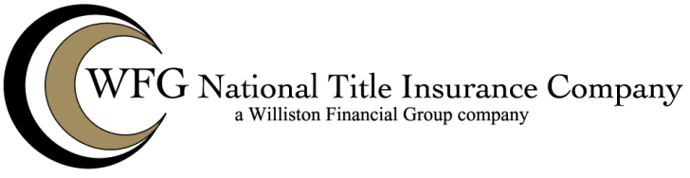

LIMITED PRE-FORECLOSURE POLICY
Issued By
WFG NATIONAL TITLE INSURANCE COMPANY

Schedule B
This policy does not insure against loss or damage by reason of:

(List matters identified in accordance with the Covered Risks.)

